LAB Assignment No 2
NAME: ABDULLAH SOHAIL
SAP: 70147165 (SEC I)

Exercise No. 1 (Interfacing with ESP32: Temp and humidity sensor)
Code: 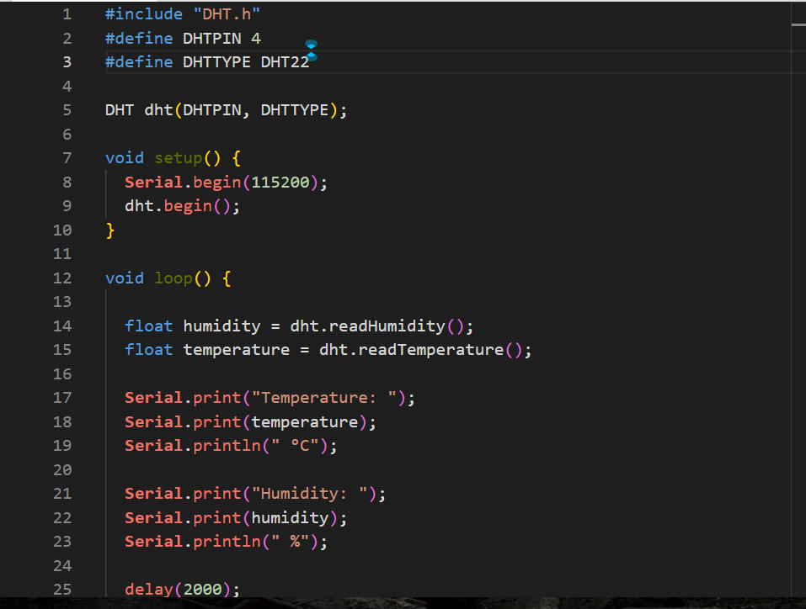

Simulation Diagram:
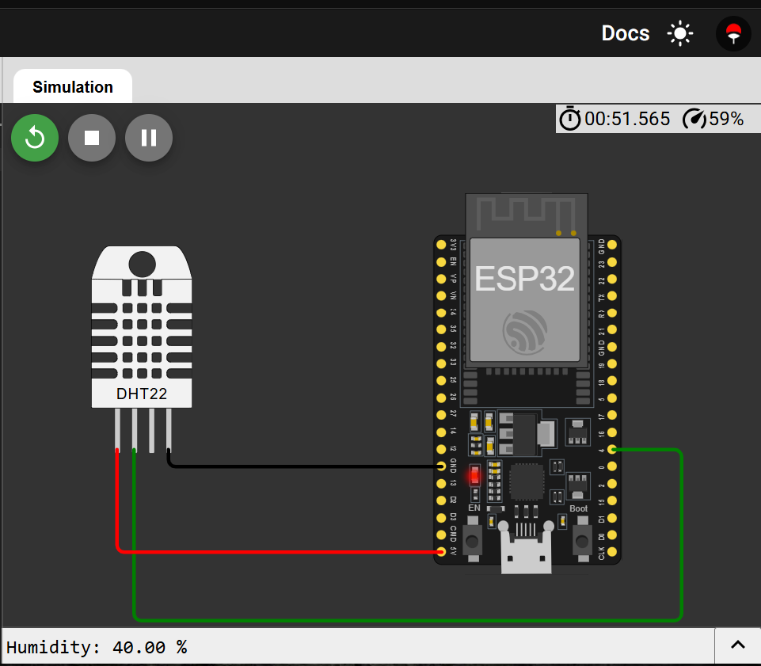
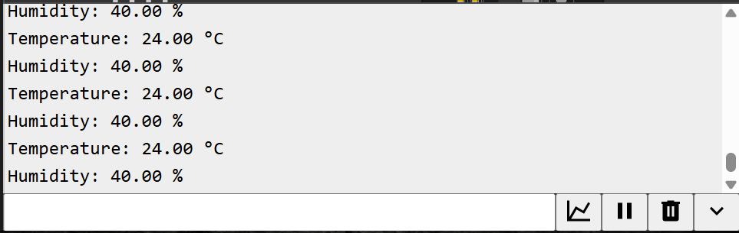

Exercise No. 2 (Interfacing with ESP32: Ultrasonic Sensor)
Code:
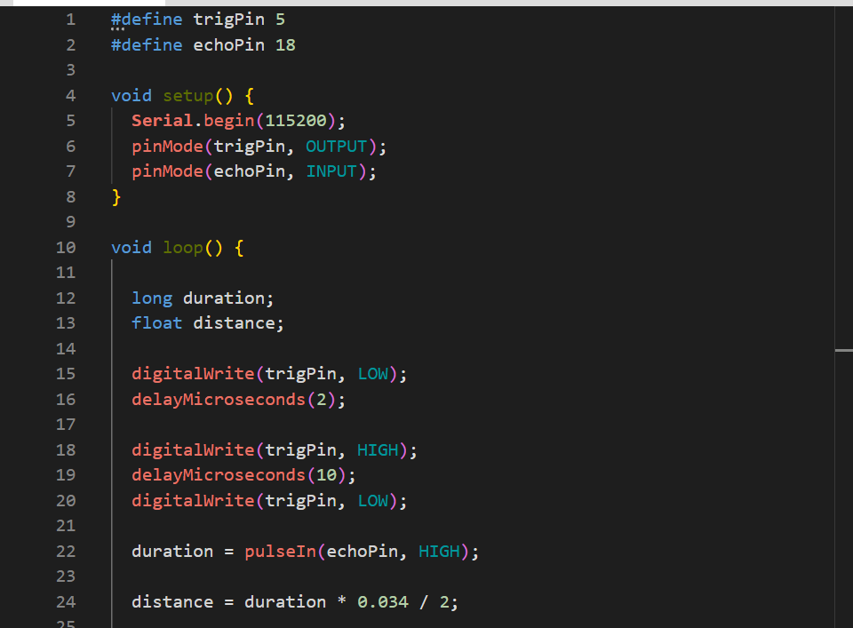
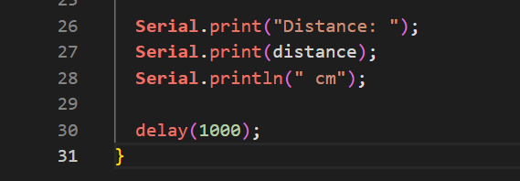

Simulation Diagram:
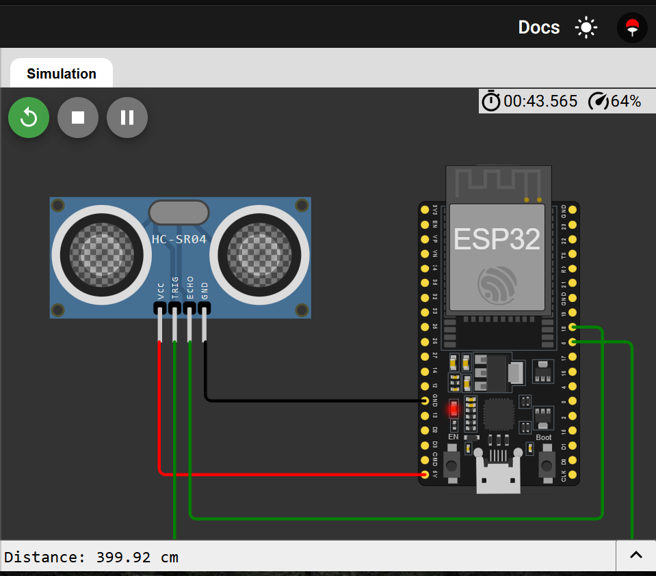
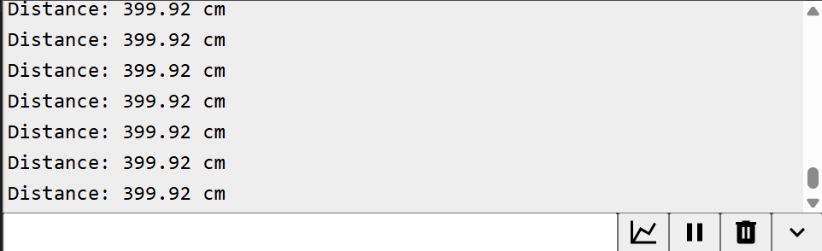

Exercise No. 3 (Interfacing with ESP32: PIR sensor)
Code: 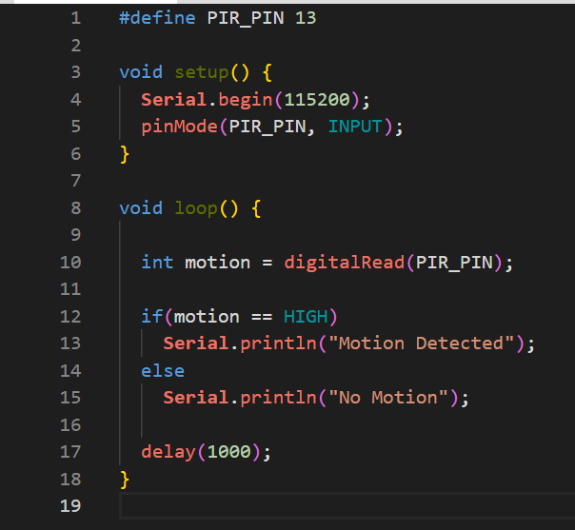

Simulation Diagram:
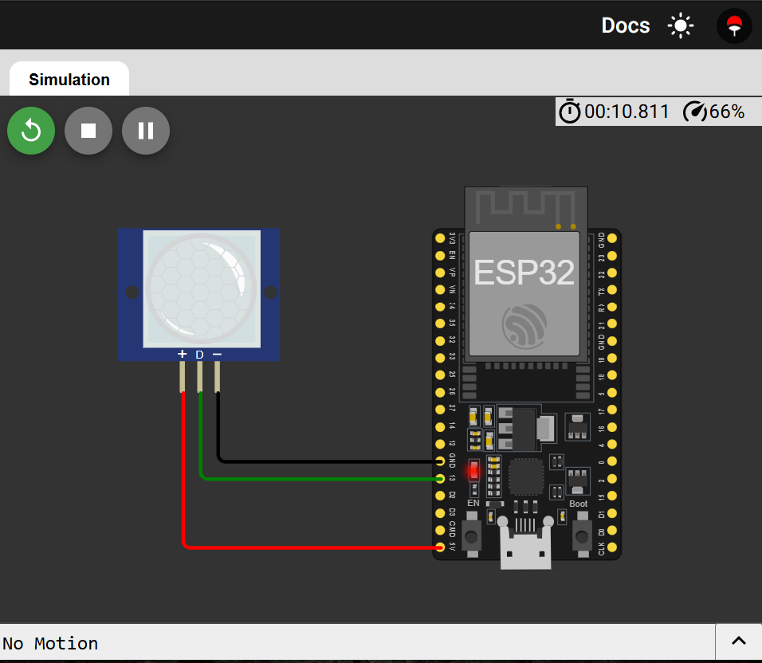
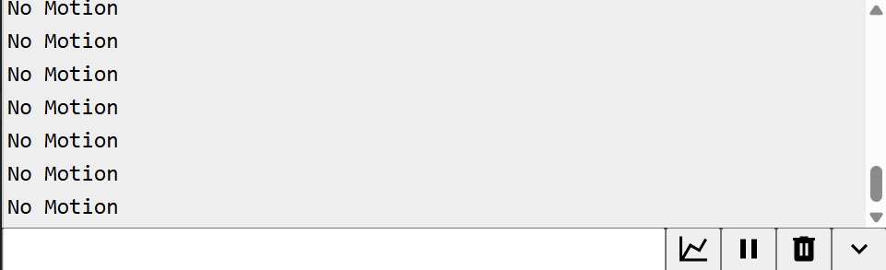

LAB Review Questions
Question 1: DHT11 with ESP32 using I2C LCD
Interface the DHT11 Temperature and Humidity Sensor with ESP32 and display the temperature and humidity values on an I2C LCD (16x2).
Tasks:
- Write the ESP32 program code to read temperature and humidity from the DHT11 sensor.
- Display the temperature and humidity values on the I2C LCD.
- Draw the complete circuit diagram / wiring diagram of ESP32, DHT11, and I2C LCD.
- Perform the simulation using Wokwi or any online simulator.
- Capture and attach screenshots of the running simulation and output.
CODE:
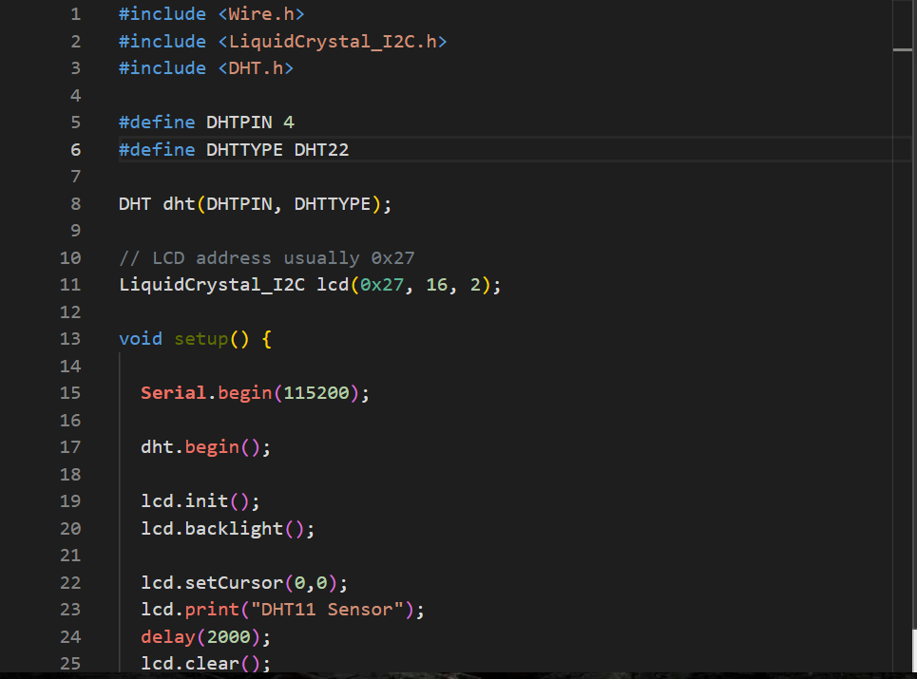
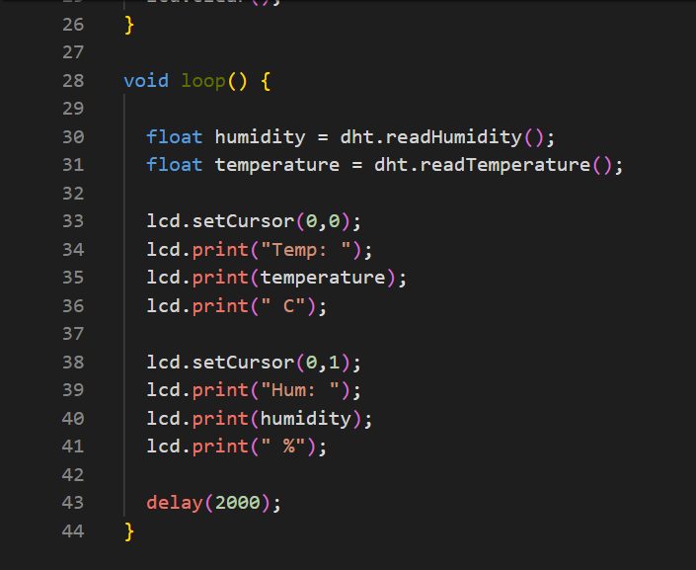

Simulation Diagram:
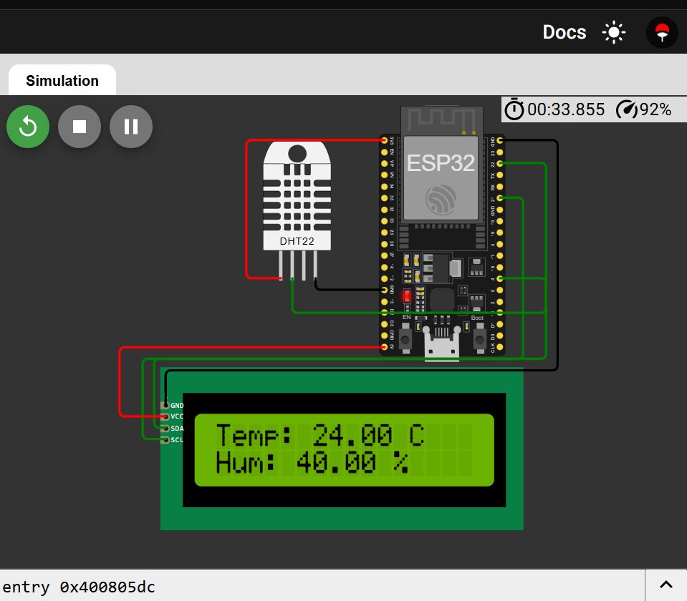
Question 2: Display Data on I2C LCD using ESP32
Create a project where ESP32 displays data on an I2C LCD.
Tasks:
- Interface I2C LCD (16x2) with ESP32.
- Write a program
- Draw the pin connection diagram between ESP32 and I2C LCD.
- Run the project in Wokwi simulation and attach the screenshot of the output.

CODE:
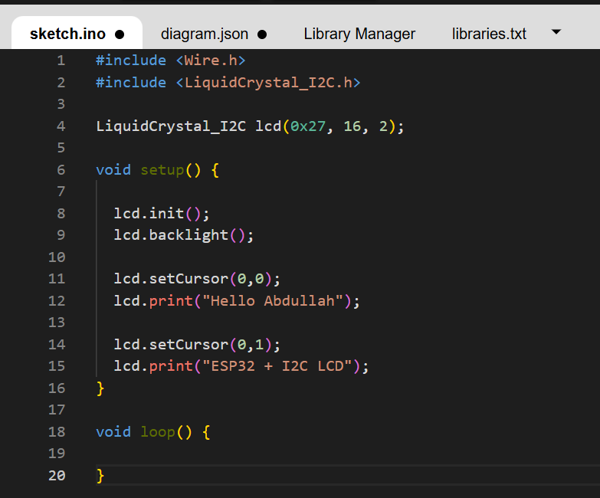

Simulation Diagram:
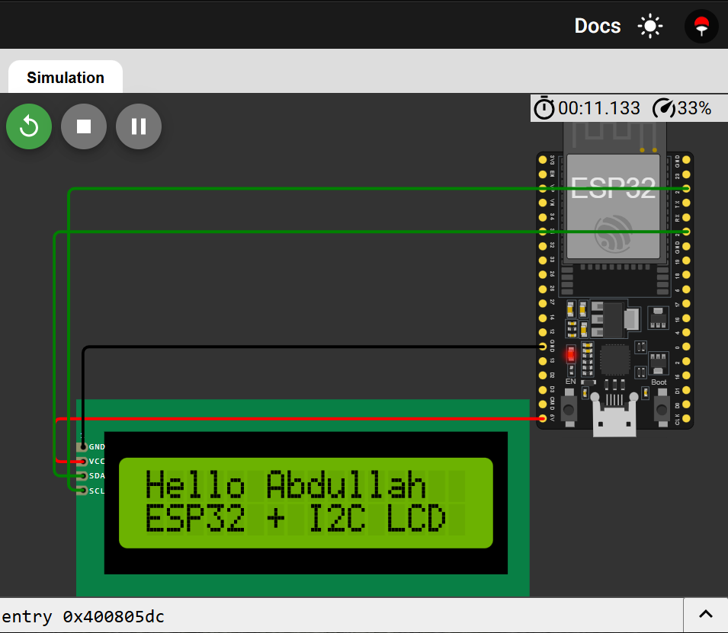
Question 3: PIR Motion Sensor with ESP32 and I2C LCD
Interface a PIR Motion Sensor with ESP32 and display the motion detection status on an I2C LCD.
Tasks:
- Write ESP32 code to read the digital output of the PIR sensor.
- Display the following messages on the LCD:
  - “Motion Detected” when motion is detected.
  - “No Motion” when no motion is detected.
- Draw the complete wiring diagram of ESP32, PIR sensor, and I2C LCD.
- Perform simulation in Wokwi and attach screenshots of the results.
CODE:
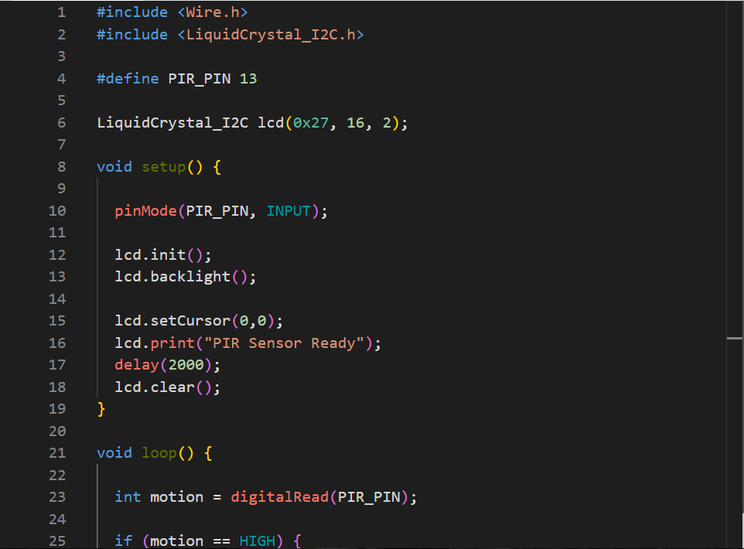
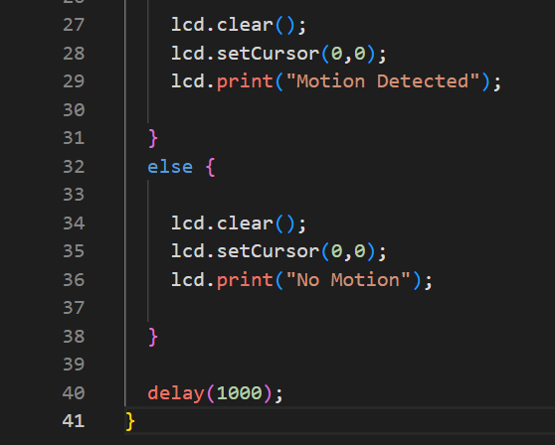
Simulation Diagram:
